**Data Visualization Using Tableau - 2**

**Assignment – 6**

**Sample Super Store Calendar** **Chart**

**Report**

**Basic**

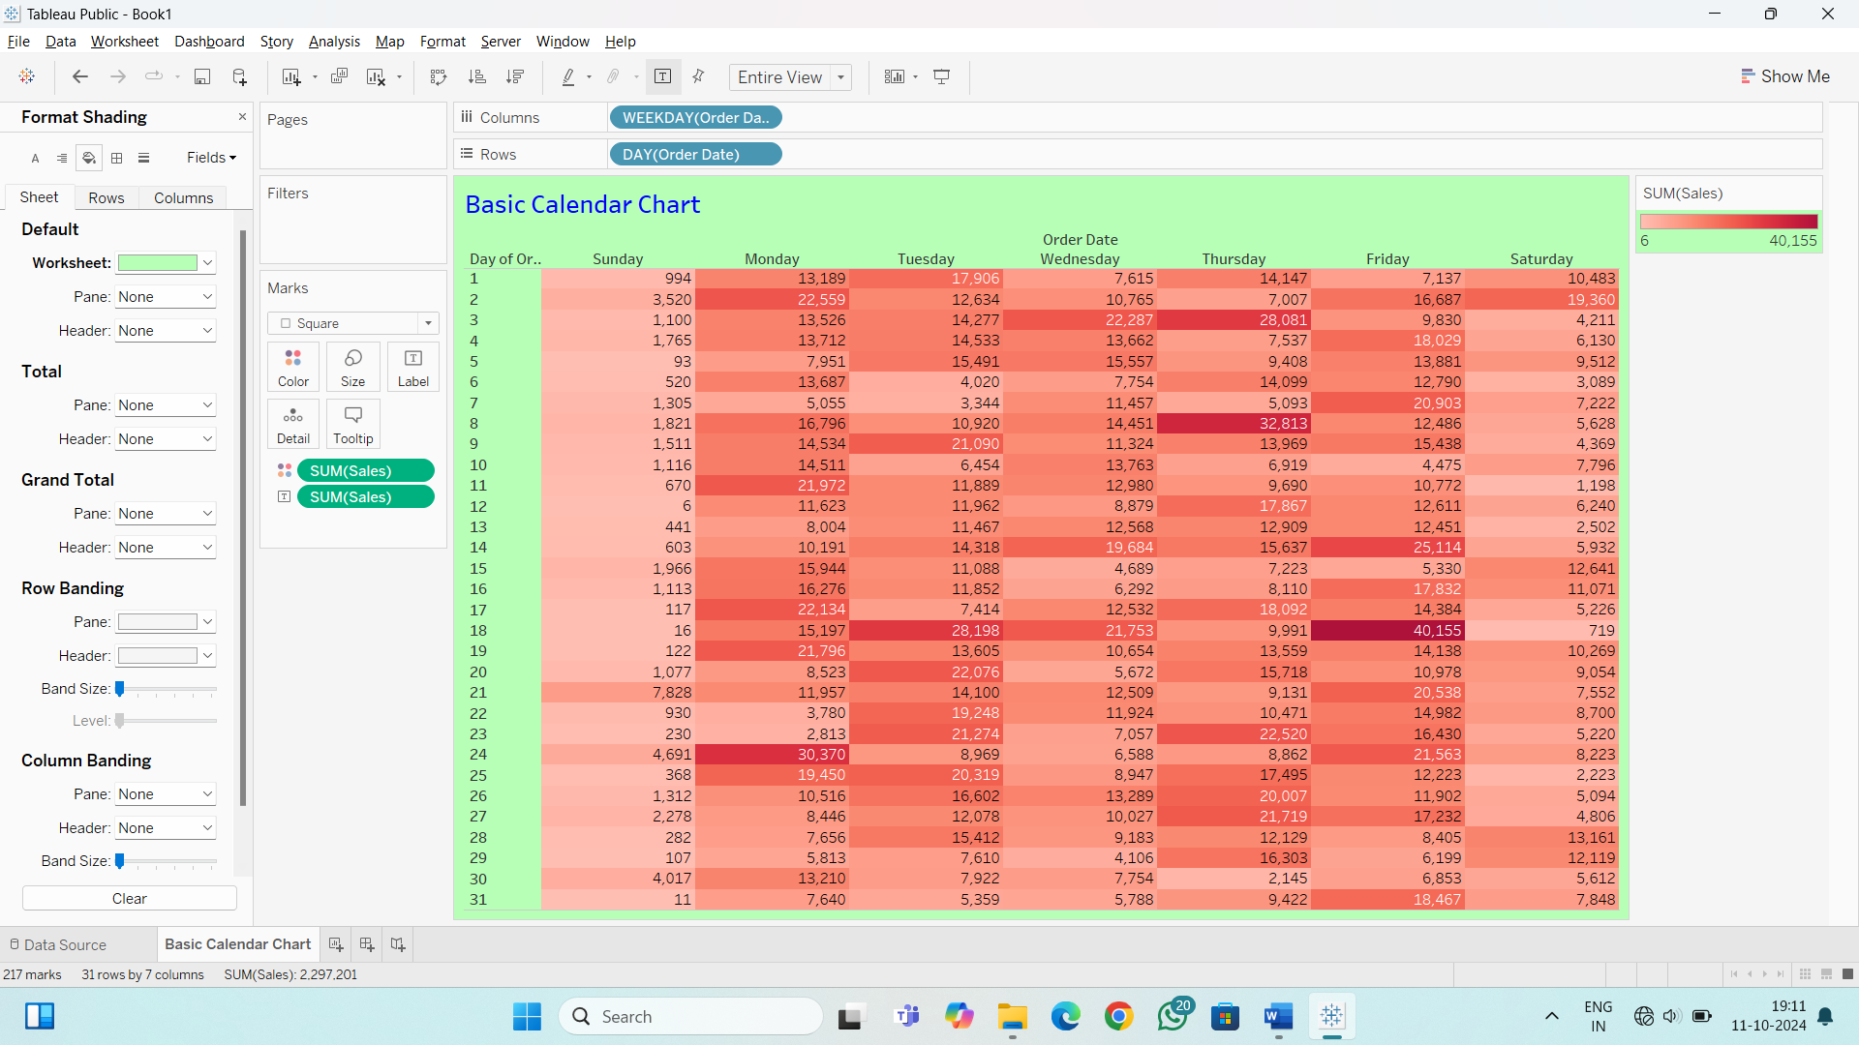

**Advance**

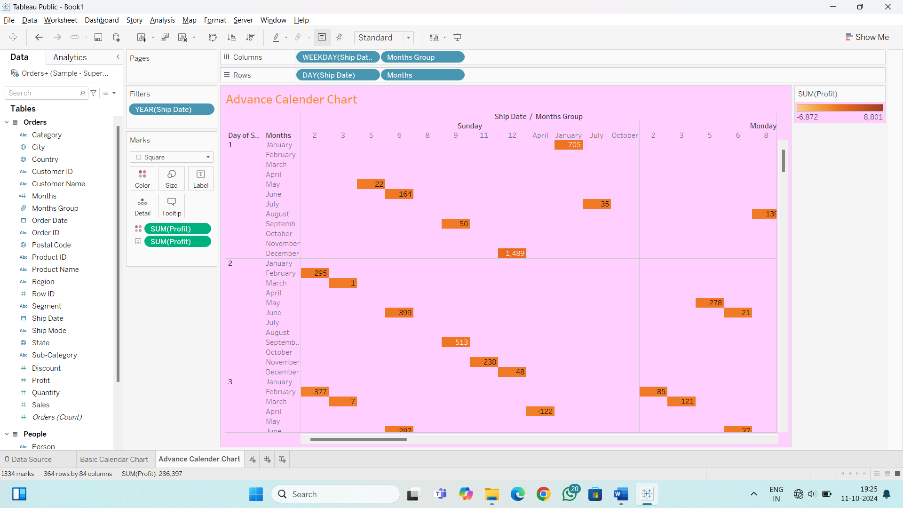

**Dashboard**

